Documentation hx19 mule flow

# Getting the source code building and deployment of the app.

First see that maven is installed.

First you need to install the jar dependencies for the hx19 java jar.

Follow this tutorial and build hx19-java: <https://github.com/hexamite/hx19-java>

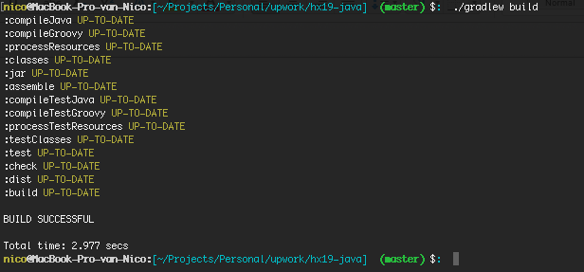

Change your directory to the hx19-java/dist/lib directory and install the libraries compiled by hx19 with following commands:

mvn install:install-file -Dfile=groovy-swing-2.1.4.jar -DgroupId=org.hexamite -DartifactId=groovy-swing -Dversion=2.1.4 -Dpackaging=jar

mvn install:install-file -Dfile=hx19-java.jar -DgroupId=org.hexamite -DartifactId=hx19-java -Dversion=0.0.1 -Dpackaging=jar

mvn install:install-file -Dfile=jeromq-0.3.2.jar -DgroupId=org.hexamite -DartifactId=jeromq -Dversion=0.3.2 -Dpackaging=jar

mvn install:install-file -Dfile=jssc.jar -DgroupId=org.hexamite -DartifactId=jssc -Dversion=0.0.1 -Dpackaging=jar

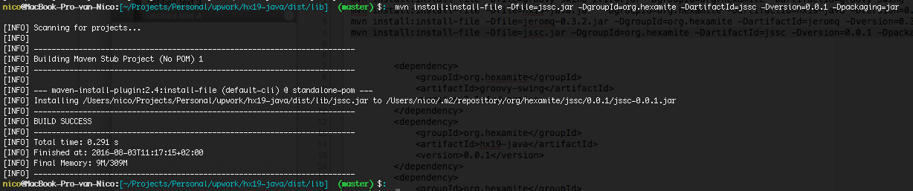

These dependencies are added in the main pom of the hx19 mule project

<dependency>

<groupId>org.hexamite</groupId>

<artifactId>groovy-swing</artifactId>

<version>2.1.4</version>

</dependency>

<dependency>

<groupId>org.hexamite</groupId>

<artifactId>hx19-java</artifactId>

<version>0.0.1</version>

</dependency>

<dependency>

<groupId>org.hexamite</groupId>

<artifactId>jeromq</artifactId>

<version>0.3.2</version>

</dependency>

<dependency>

<groupId>org.hexamite</groupId>

<artifactId>jssc</artifactId>

<version>0.0.1</version>

</dependency>

You need access to a mule licensed maven repo to build the project.

Try to build the hx19 mule project with: maven clean install.

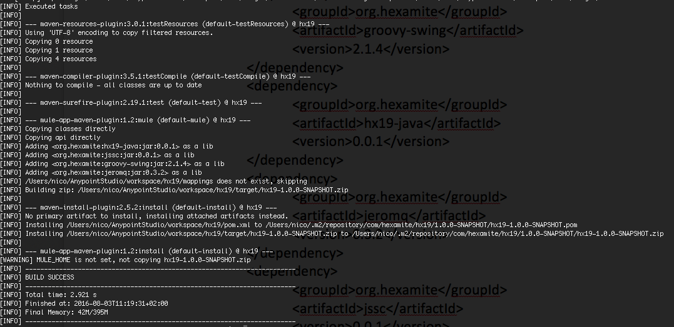

Now you should have a file called hx19-1.0.0-SNAPSHOT.zip in the target folder. If you place this file in the mule apps folder the project will be automatically deployed.

## Running test scenario’s

These tests are done with postman. You can find this app inside google chrome.

If you want mocking on then you can add following header. This will always result in the same value.

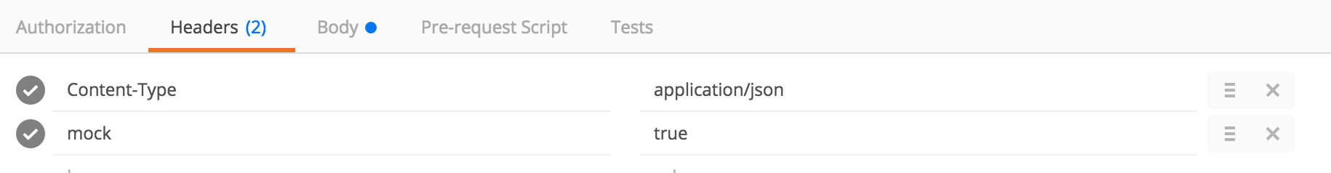

### Posting a message



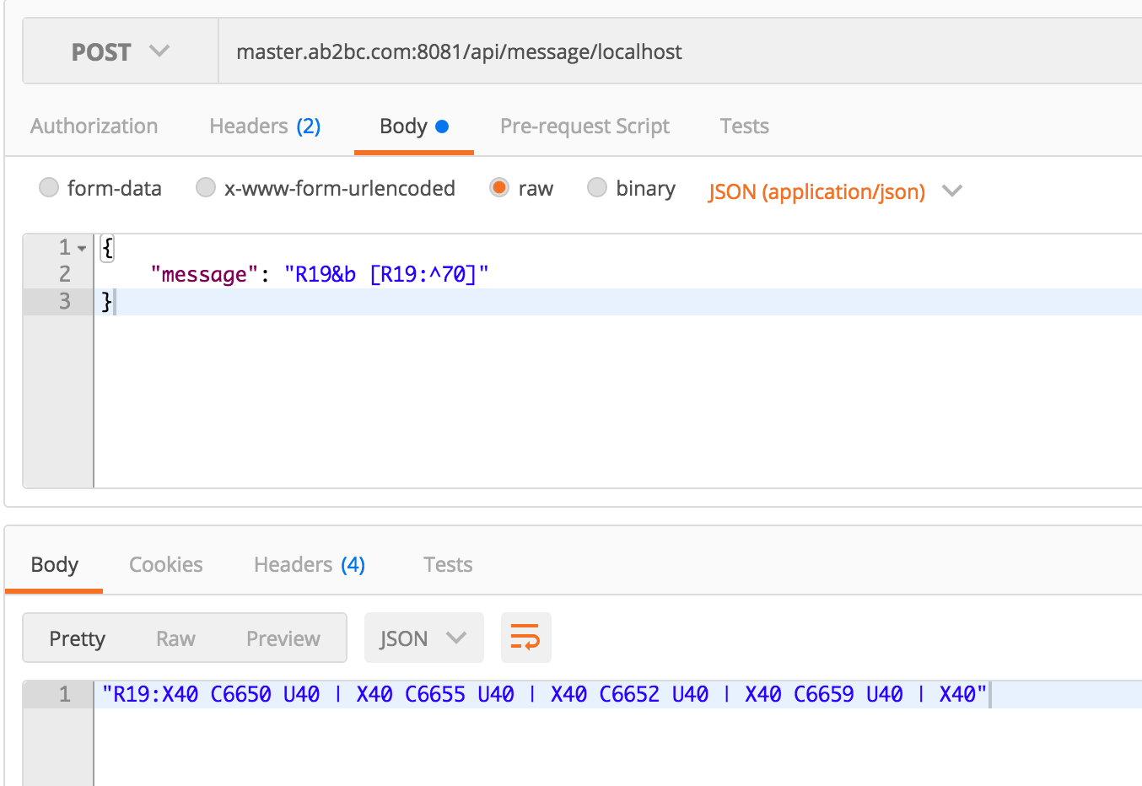

### Getting a monitor



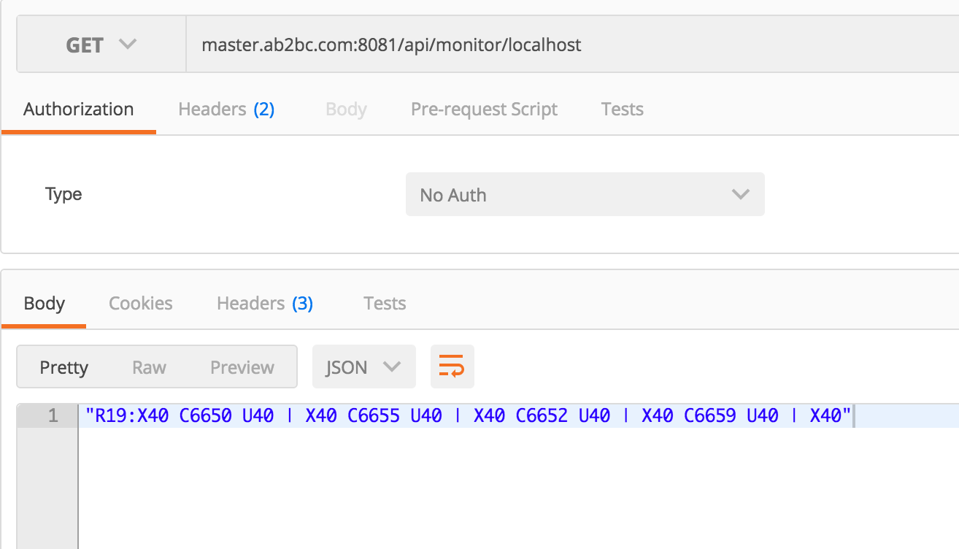

### Posting a file:



